과제 1

**import** java.util.Scanner;

**public** **class** Test {

**public** **static** **void** main(String[] args) {

// **TODO** Auto-generated method stub

**int** num;

Scanner sc = **new** Scanner(System.***in***);

System.***out***.println("피보나치 수열을 진행할 정수를 입력하세요: ");

num = sc.nextInt();

*fib*(num);

System.***out***.println("\n20145165 정균모");

}

**static** **void** fib(**int** num) {

**int** a = 0;

**int** b = 1;

**int** c;

**for** (**int** i = 0; i < num; i++) {

System.***out***.print(a + " ");

c = a + b;

a = b;

b = c;

}

}

}

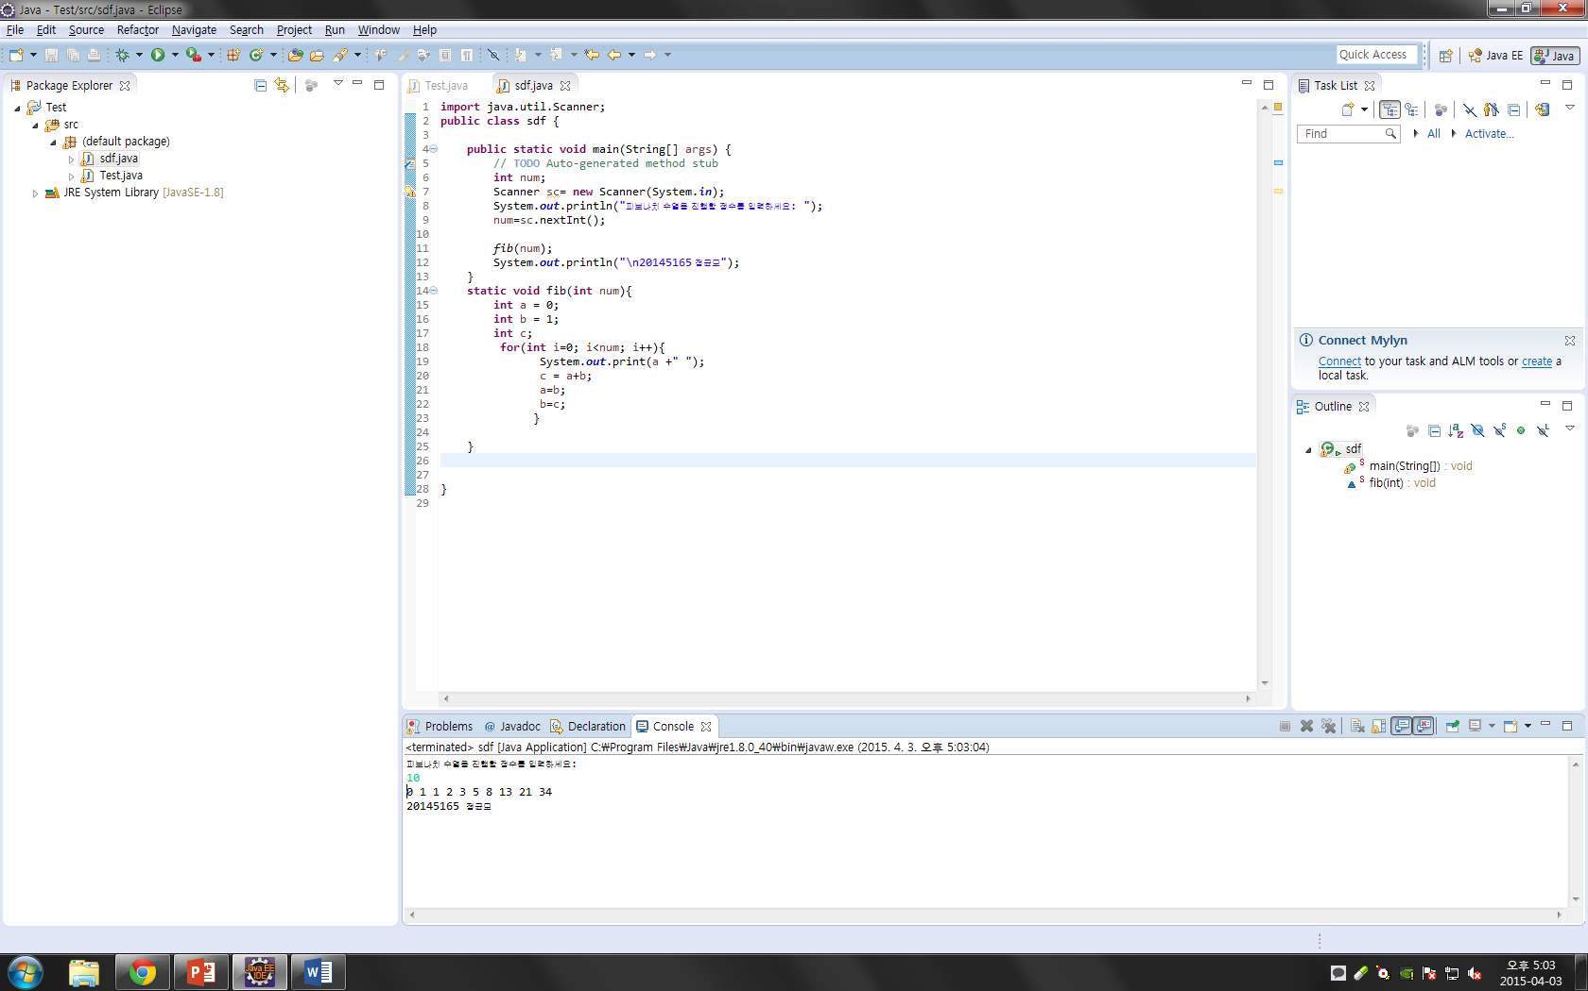

**public** **class** Test {

**public** **static** **void** main(String[] args) {

// **TODO** Auto-generated method stub

**int** DISKS = 3;

*move*(DISKS, 'A', 'B', 'C');

System.***out***.println("\n 20145165 정균모");

}

**public** **static** **void** move(**int** n, **char** from, **char** tmp, **char** to) {

**if** (n == 1) {

System.***out***.println(n + "를 " + from + "에서 " + to + "로 옮깁니다.");

} **else** {

*move*(n - 1, from, to, tmp);

System.***out***.println(n + "를 " + from + "에서 " + to + "로 옮깁니다.");

*move*(n - 1, tmp, from, to);

}

}

}

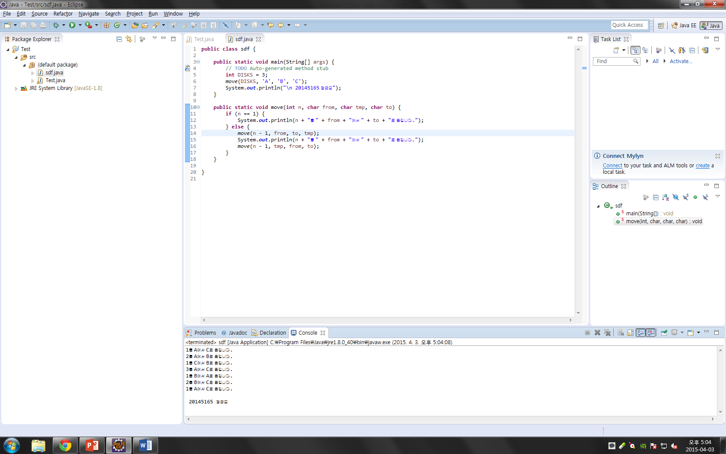

**import** java.util.Scanner;

**public** **class** sdf {

**public** **static** **void** main(String[] args) {

// **TODO** Auto-generated method stub

**int** num1, num2;

Scanner sc = **new** Scanner(System.***in***);

System.***out***.println("최대공략수를 구하려는 정수 2개를 입력하세요 :");

num1 = sc.nextInt();

num2 = sc.nextInt();

System.***out***.println(*gcm*(num1, num2));

System.***out***.println("\n 20145165 정균모");

}

**static** **int** gcm(**int** a, **int** b) {

**int** result = 0;

**int** small = 0;

**int** i;

**if** (a > b) {

small = b;

} **else** {

small = a;

}

**for** (i = small; i >= 1; i--) {

**if** (a % i == 0 && b % i == 0) {

**break**;

}

}

result = i;

**return** result;

}

}

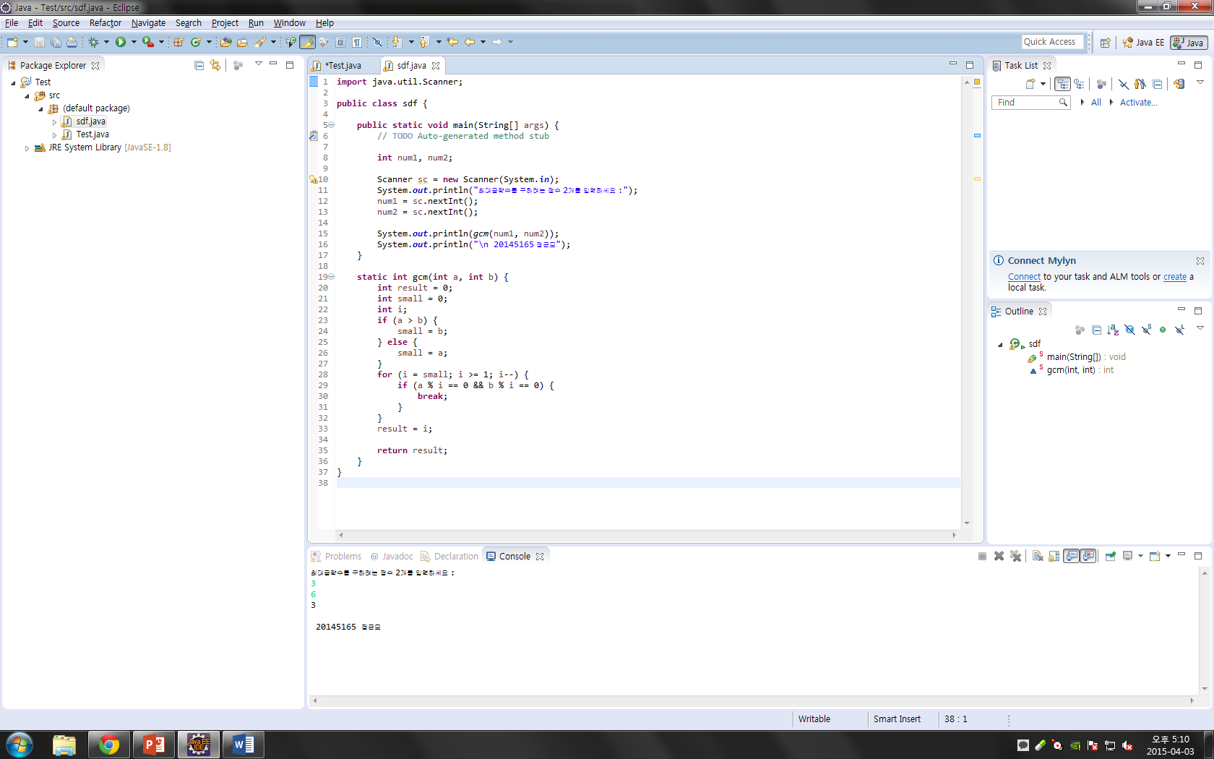

**import** java.util.Scanner;

**public** **class** Test {

**public** **static** **void** main(String[] args) {

// **TODO** Auto-generated method stub

String s;

Scanner sc = **new** Scanner(System.***in***);

System.***out***.println("문자열을 입력하세요 : ");

s = sc.nextLine();

System.***out***.println("재기함수 :" + *Palindrom_fu*(s, 0, s.length() - 1));

System.***out***.println("반복문 :" + *Palindrom_ru*(s, 0, s.length() - 1));

System.***out***.println("\n 20145165 정균모");

}

**private** **static** **boolean** Palindrom_fu(String s, **int** l, **int** r) {

l = s.length();

**int** i;

r = l - 1;

**for** (i = 0; i < r / 2; i++) {

**if** (s.charAt(i) == '-') {

**if** (s.charAt(++i) != s.charAt(r--)) {

**return** **false**;

}

**if** (s.charAt(r) != '-') {

**return** **false**;

}

r--;

} **else** **if** (s.charAt(i) != s.charAt(r--)) {

**return** **false**;

}

}

**return** **true**;

}

**private** **static** **boolean** Palindrom_ru(String s, **int** l, **int** r) {

**for** (**int** i = 0; i < r; i++) {

**if** (s.charAt(i) != s.charAt(r - i)) {

**return** **false**;

}

}

**return** **true**;

}

}

